A CRM APPLICATION FOR THECHAISHOP&CO

USER STORY
As a Sales Representative at TheChaiShop&Co, the objective is to efficiently manage customer relationships and streamline sales processes using the CRM application.
The system enables easy access and updating of employer details and distinguishes between online and offline customer records using record types to allow personreports alized interactions.
The application automates sales calculations such as order quantity and total bill amount to ensure accuracy and efficiency in transactions.
Additionally, it supports the generation of insightful and dashboards to summarize and analyze sales data for effective decision-making and strategy development.
The system also automates birthday email notifications to customers, including special offers to enhance engagement and loyalty.

1. INTRODUCTION
1.1 Project Overview
The project titled “A CRM Application for TheChaiShop&Co” focuses on developing a Customer Relationship Management (CRM) system using Salesforce.
The system manages customer, employer, and enterprise accounts efficiently. It automates sales processes, maintains structured customer records, generates analytical reports, and improves customer engagement through automated notifications.
The user story and project objectives define the functional scope of the application.

1.2 Purpose
The purpose of this project is to:
- Streamline customer relationship management
- Automate billing and order calculations
- Improve data accuracy
- Enable data-driven decision-making
- Enhance customer engagement through email automation

2. IDEATION PHASE
2.1 Problem Statement
PS | I am | I’m trying to | But | Because | Which makes me feel
PS-1 | Sales Representative | Manage customer orders and billing | Calculations are often incorrect | Order quantity and billing are manual | Stressed and inefficient
PS-2 | Store Manager | Monitor sales and customer records | Reports are delayed and incomplete | Data is stored in multiple files | Confused and dissatisfied
PS-3 | Customer | Receive personalized offers and updates | I do not get timely notifications | There is no automated communication | Disconnected and undervalued

2.2 Empathy Map Canvas
- Target Users
- Sales Representatives
- Managers
- System Administrators
- Business Analysts
- Empathy Analysis

Aspect | Description
Think & Feel | Need accurate customer data and reports
Hear | Feedback from management
See | Multiple registers and spreadsheets
Say & Do | Enter data manually
Pain | Errors, delays, data loss
Gain | Automation and fast reporting

2.3 Brainstorming
- Brainstormed Ideas
- Manual CRM system
- Excel-based management
- Web-based CRM
- Salesforce-based CRM
- Automated email system
- Selected Idea
- Salesforce-based CRM Application for TheChaiShop&Co.

- REQUIREMENT ANALYSIS PHASE
  - Customer Journey Map
Journey Stages:

- Login
- Access CRM Application
- Enter Customer Data
- Generate Orders
- Calculate Bills
- View Reports
- Decision Making

3.2 Solution Requirements
Functional Requirements
FR No | Requirement
FR-1 | User Login
FR-2 | Object Creation
FR-3 | Data Entry
FR-4 | Billing Automation
FR-5 | Report Generation
FR-6 | Email Automation

Non-Functional Requirements
NFR-1: Usability
The system is designed to be easy to use for sales representatives, managers, administrators, and analysts without requiring technical training.
Requirements include:
- Simple and intuitive user interface
- Clear navigation menus
- Easy-to-understand forms
- User-friendly dashboards
Example: A new sales employee can log in, enter customer details, and generate orders within minutes.

NFR-2: Security
The system ensures protection of customer and business data from unauthorized access.

Requirements include:

- Role-based access control
- Secure login authentication
- Encrypted data storage
- Data backup and recovery

NFR-3: Reliability
The CRM system ensures consistent operation and accurate data storage without loss.
Requirements include:
- Automatic data saving
- Regular backups
- Error handling mechanisms
- Stable cloud environment

NFR-4: Performance
The system responds quickly and handles large volumes of data efficiently.
Requirements include:
- Fast page loading
- Quick report generation
- Smooth dashboard rendering
- Minimal delay

NFR-5: Availability
The system ensures continuous accessibility whenever required.
Requirements include:
- 24/7 availability
- Minimal downtime
- Cloud-based hosting
- Disaster recovery mechanisms

NFR-6: Scalability
The system supports business growth without performance degradation.
Requirements include:
- Ability to handle increasing users
- Support for growing customer data
- Expandable storage
- Maintained system speed

3.3 Data Flow Diagram

User → Salesforce UI → Custom Objects → Validation Rules → Flows → Reports → Dashboards

3.4 Technology Stack

Layer | Technology
Frontend | Salesforce Lightning
Database | Salesforce Cloud
Automation | Flows
Backend | Salesforce Platform
Analytics | Reports & Dashboards

4. PROJECT DESIGN PHASE
4.1 Problem–Solution Fit
The CRM system replaces manual records with automated data management. Cloud storage prevents data loss, dashboards improve analysis, and real-time reports eliminate delays.
This ensures accurate and timely generation of business insights.

4.2 Proposed Solution

Parameter | Description
User Login & Authentication | Secure login using valid credentials
Customer Record Management | Create, view, update, and delete customer details
Employer & Enterprise Management | Manage employer and enterprise accounts
Order Management | Create and track customer orders
Automated Billing System | Automatically calculate total bill using formula fields
Validation Rules | Ensure accurate data entry
Record Types & Page Layouts | Different layouts for customer categories
Global Picklists | Standardized values for common fields
Email Notification System | Automated birthday and offer emails
Workflow & Flow Automation | Automated record updates and alerts
Report Generation | Generate detailed sales and customer reports
Dashboard Visualization | Real-time analytics and charts
Data Backup & Recovery | Secure cloud storage and recovery
User Role Management | Controlled access using profiles and permissions

4.3 Solution Architecture
Architecture Layers:
- Presentation Layer – Lightning UI
- Application Layer – Flows and Business Logic
- Data Layer – Custom Objects
- Analytics Layer – Reports and Dashboards
This layered architecture ensures modularity, scalability, and maintainability of the CRM system.

5. PROJECT PLANNING & SCHEDULING

5.1 Project Planning
- The project followed an Agile-based development approach with defined milestones and sprints.
- A Salesforce Developer account was created to set up the development environment.
- Custom objects were designed to store customer, employer, and enterprise data.
- Custom tabs and a Lightning Application were developed for easy system navigation.
- Fields, relationships, and global picklists were configured to ensure data consistency.
- Page layouts and record types were created based on user roles and customer categories.
- Validation rules were implemented to prevent incorrect data entry.
- Email templates and automated flows were developed for customer notifications.
- Reports and dashboards were created for performance monitoring and analysis.
- Regular sprint reviews and testing were conducted to track progress and resolve issues.
Sprint | Functional  Requirement  (Epic) | User  Story  Number | User Story / Task | Story Points | Priority | Team Member  s
Sprint-1 | Developer Setup | USN-1 | As an admin, I want to create a Salesforce developer account so  that I can configure and deploy the  TheChaiShop&Co CRM application. | 1 | High | R.Vinothini
Sprint-1 | Data Modeling | USN-2 | As an admin, I want to create  Customer, Employer, and  Enterprise objects so that business data can be stored and managed systematically. | 3 | High | D.Rajalatchi
Sprint-2 | Data Modeling | USN-3 | As a user, I want separate tabs for  each object so that I can easily navigate and manage CRM records within the application. | 3 | High | K.Parkavi
Sprint | Functional  Requirement  (Epic) | User  Story  Number | User Story / Task | Story Points | Priority | Team Member  s
Sprint-2 | Data Modeling | USN-4 | As a manager, I want a dedicated Lightning App so that all CRM operations are accessible from a single dashboard. | 3 | High | H.Sharmilabanu
Sprint-2 | Data Modeling | USN-5 | As an admin, I want to create customer and order fields so that complete sales and billing details can be captured accurately. | 5 | Medium | R.Vinothani
Sprint-2 | Data Modeling | USN-6 | As a user, I want customized page layouts for different record types so that only relevant information is displayed during data entry | 5 | High | D.Rajaltchi
Sprint-2 | Data Modeling | USN-7 | As a manager, I want separate record types for Retail and Enterprise customers so that different business categories can be managed efficiently. | 5 | Medium | K.Parkavi
Sprint-3 | Automation | USN-8 | As a system, I want to validate customer details and order inputs so that incorrect data entries are prevented. | 3 | High | H.Sharmilabanu
Sprint-3 | Automation | USN-9 | As a system, I want automated flows to send email notifications so that customers receive timely updates and offers. | 5 | High | R.Vinothani
Sprint-4 | Automation | USN-10 | As a system, I want to automatically calculate billing amounts so that invoices are generated without manual effort. | 5 | High | D.Rajalatchi
Sprint-5 | Reports | USN-11 | As a manager, I want sales and customer reports so that I can monitor business performance and make informed decisions. | 4 | High | K.Parkavi
Sprint-6 | Dashboards | USN-12 | As a manager, I want visual dashboards so that I can quickly analyze sales, customers, and enterprise performance. | 4 | Medium | H.Sharmilabanu

6. Project Development Phase:

Project Flow
Milestone 1 : Creation of developer account
Milestone 2 : Object Creation
Milestone 3 : Tabs
Milestone 4 : The Lightning App
Sprint | Total Story Points | Duratio n | Sprint Start Date | Sprint End Date (Planned) | Story Points  Completed  (as on  Planned End  Date) | Sprint Release Date (Actual)
Sprint-1 | 20 | 2 Days | 28 Feb 2026 | 02 Mar 2026 | 20 | 02 Mar 2026
Sprint-2 | 20 | 2 Days | 01 Mar 2026 | 03 Mar 2026
Sprint-3 | 20 | 2 Days | 02 Mar 2026 | 04 Mar 2026
Sprint-4 | 20 | 2 Days | 03 Mar 2026 | 05 Mar 2026
Milestone 5 : Global Picklist
Milestone 6 : Fields and Relationships
Milestone 7 : Creation of Page Layout
Milestone 8 : Creation of Record Types
Milestone 9 : Validation rules
Milestone 10 : Email Templates
Milestone 11 : Flows
Milestone 12 : Reports and Dashboards
Milestone 13 : Conclusion

Milestone 1 – Salesforce Developer Account Creation
A Salesforce Developer Organization was created to establish the development environment for the CRM application.
The developer account was registered with required organizational details including developer role, company information, country, and username credentials.
The account was successfully verified through email authentication. Secure login credentials were configured with password setup and security verification.
Upon activation, the Salesforce Setup interface was accessed to begin system configuration.
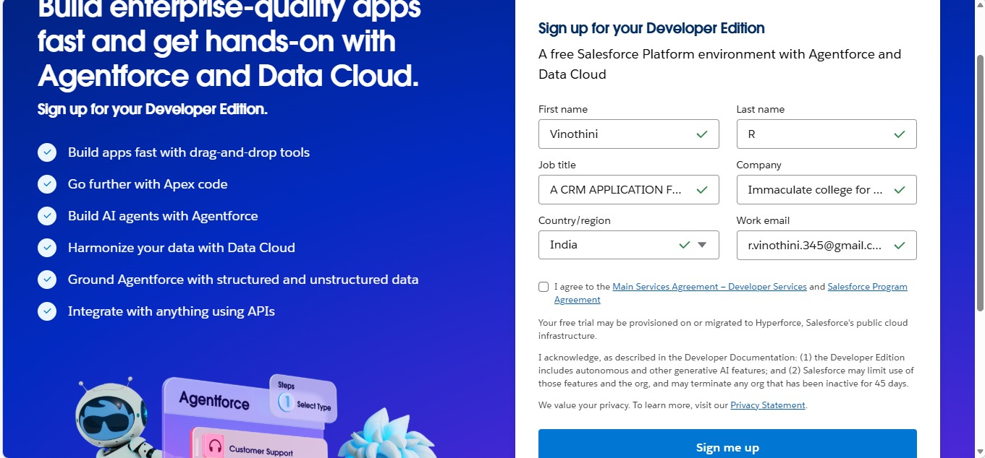

Milestone 2 – Custom Object Creation
Custom objects were created to store and manage business data systematically within the CRM system.

Employer Account Object
A custom object named Employer Account was created with the following configuration:
- Record Name: Employer Account Name
- Data Type: Text
- Reports Enabled
- Activities Enabled
- Field History Tracking Enabled
- Search Functionality Enabled
This object is used to store employer-related information within the organization.
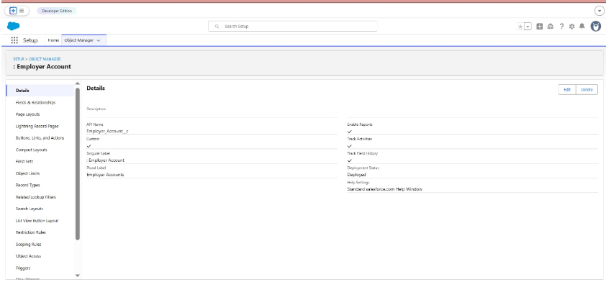

Customer Account Object
A custom object named Customer Account was created with the following configuration:
- Record Name: Customer Account Name
- Data Type: Text
- Reports Enabled
- Activities Enabled
- Field History Tracking Enabled
- Search Functionality Enabled
This object manages individual customer records and sales-related details.
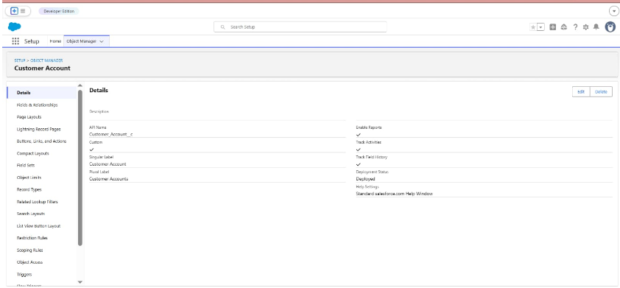

Enterprise Account Object
A custom object named Enterprise Account was created with the following configuration:
- Record Name: Enterprise Account Name
- Data Type: Text
- Reports Enabled
- Activities Enabled
- Field History Tracking Enabled
- Search Functionality Enabled
This object supports enterprise-level business customer management.
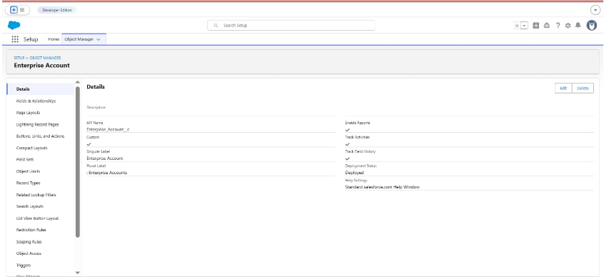

Milestone 3 – Custom Tabs Creation
Custom tabs were created for the following objects:
- Employer Accounts
- Customer Accounts
- Enterprise Accounts
Tabs were configured with appropriate tab styles and profile visibility settings.
The tabs were appended to users’ existing personal customizations to ensure accessibility within the CRM application.
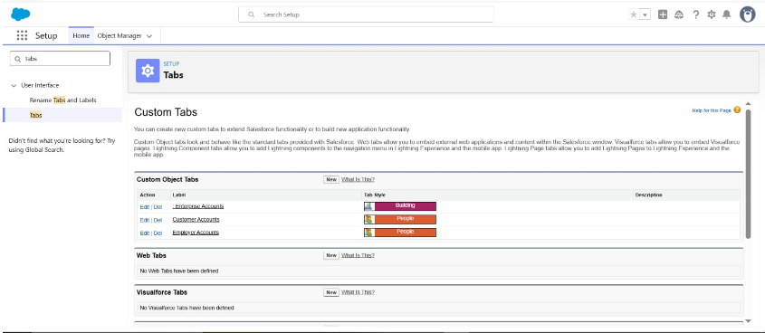

Milestone 4 – Lightning Application Development
A Lightning Application named TheChaiShop&Co was developed to integrate all CRM components into a unified interface.
Application Configuration:
- Navigation Style: Standard Navigation
- Supported Form Factors: Desktop and Mobile
- Utility Bar Alignment: Default
- Assigned Profile: System Administrator
The following navigation items were included:
- Customer Accounts
- Employer Accounts
- Enterprise Accounts
- Reports
- Dashboards
This Lightning App serves as the primary operational interface for CRM users.
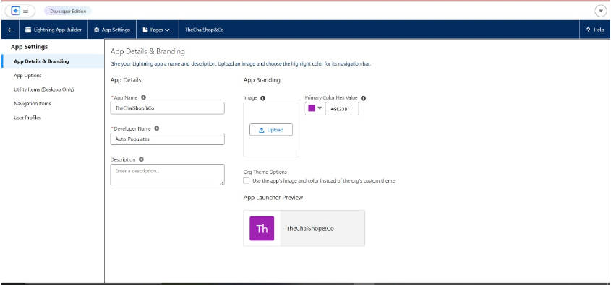

Milestone 5 – Global Picklist Creation
Global Picklist Value Sets were created to maintain standardized field values across multiple objects.
The following global picklists were implemented:

Gender
Values:
- Male
- Female
- Others

Items
Values included tea powders, biscuits, cookies, and gift hamper categories such as:
- Platinum Tea Powder
- Double Delight Tea Powder
- Super Dust Tea Powder
- Osmania Biscuits (Value Pack)
- Osmania Biscuits (Premium Pack)
- Dry Fruit Biscuits
- Fruit Biscuits
- Salt Biscuits
- Multigrain Biscuits
- Ragi Biscuits
- Double Choco Chip Cookies
- Butter Almond Cookies
- Melting Moments Cookies
- Honey Oats Cookies
- Delight Box
- Signature Box
- Assorted Box

Payment Mode
Values:
- GPay
- PhonePe
- Paytm
- Credit or Debit Card
- Cash

Type of Items
Values:
- Tea Powder
- Cookies
- Gift Hampers
These global picklists ensure uniformity and prevent inconsistent data entry.
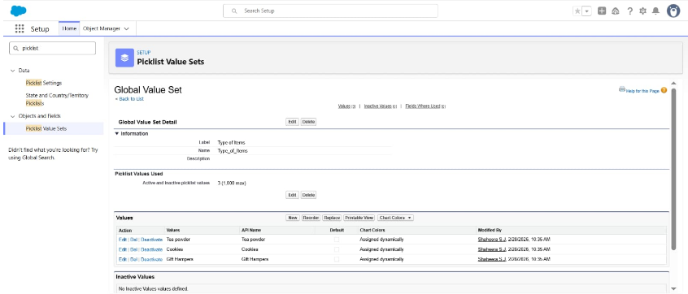

Milestone 6 – Fields and Relationships
Custom fields and relationships were created across all objects to capture detailed business information.

Employer Account – Fields Implemented
The following fields were created:
- First Name (Text, Required)
- Last Name (Text, Required)
- Gender (Picklist – Global Value Set: Gender, Required)
- Phone Number (Phone, Required)
- Email ID (Email, Required)
- Date of Birth (Date, Required)
- Aadhaar Number (Text – Length 12)
- PAN Details (Text – Length 10)
- Designation (Picklist – Manager, Finance & Accounting, Kitchen Staff, Cashier, Servers)
- Salary (Currency)
These fields capture employer demographic and professional details.
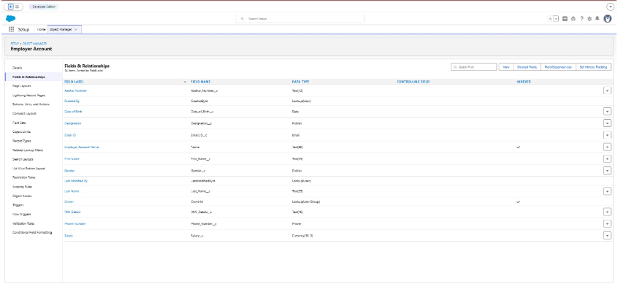

Customer Account – Fields Implemented
The following fields were created:
- First Name (Text, Required)
- Last Name (Text, Required)
- Gender (Picklist – Global Value Set: Gender, Required)
- Phone Number (Phone, Required)
- Date of Birth (Date, Required)
- Birthday Today? (Formula – Checkbox)
- Email ID (Email, Required)
- Address (Text)
- Type of Items (Multi-Select Picklist – Global Value Set)
- Products Purchased (Multi-Select Picklist – Global Value Set: Items)
- Chai (Multi-Select Picklist)
- Payment Mode (Picklist – Global Value Set)
- Associated Employer (Lookup Relationship to Employer Account)
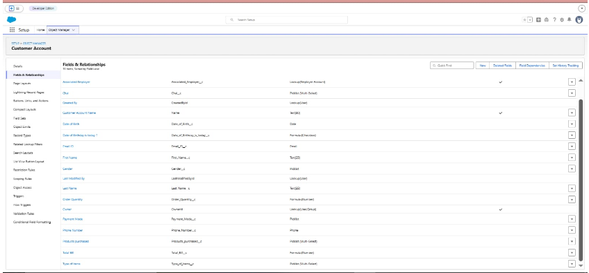

Formula Fields Implemented
Order Quantity (Formula – Number):
Automatically calculates total quantity based on selected products and chai items.
Total Bill (Formula – Number):
Automatically calculates total billing amount based on predefined product pricing values.
These formula fields eliminate manual billing calculations and improve transaction accuracy.

Enterprise Account – Fields Implemented
The following fields were created:
- Enterprise Name (Text, Required)
- Phone Number (Phone, Required)
- Email ID (Email, Required)
- Address (Text)
- Type of Items (Multi-Select Picklist – Global Value Set)
- Products Purchased (Multi-Select Picklist – Global Value Set: Items)
- Associated Employer (Lookup Relationship to Employer Account)
- Order Quantity (Formula – Number)
- Total Bill (Formula – Number)
- Payment Mode (Picklist – Global Value Set)
These configurations enable enterprise-level order tracking and automated billing.
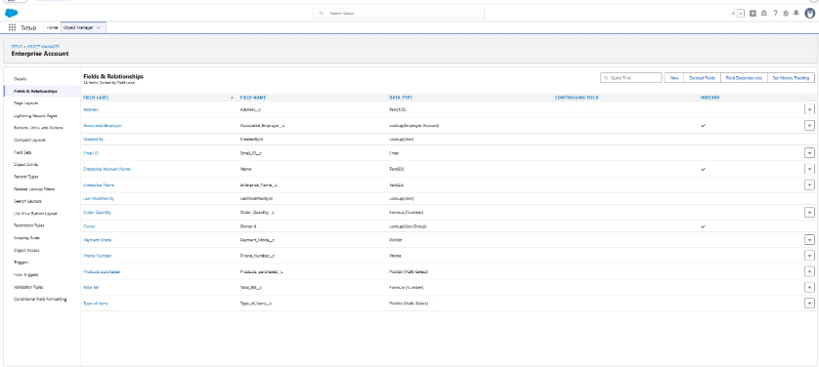

Milestone 7 – Page Layout Configuration
To provide personalized field visibility in the Customer Account object, two separate page layouts were created.
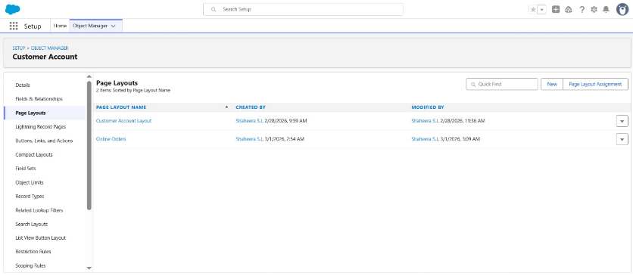

Online Orders Page Layout
A custom page layout titled Online Orders was created for the Customer Account object.
All relevant fields required for managing online transactions were arranged appropriately to ensure structured data entry and improved usability.
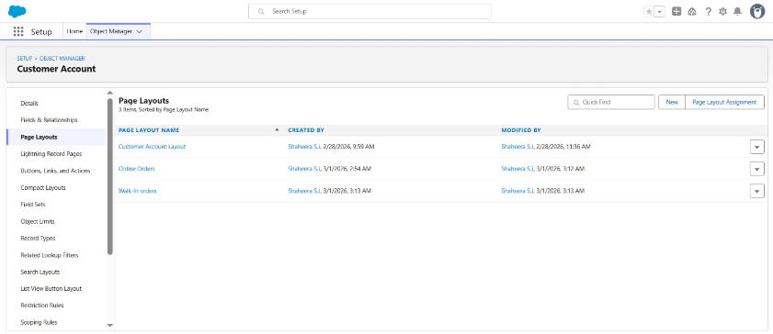

Walk-In Orders Page Layout
A second page layout titled Walk-In Orders was created for offline customer transactions.
Required fields were organized to support in-store order management.
These layouts enable customized field presentation based on customer interaction type.
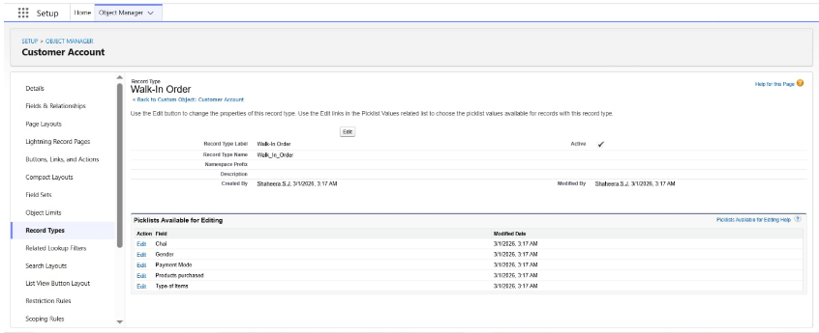

Milestone 8 – Record Types Implementation
To differentiate customer records and categorize transactions effectively, two record types were implemented for the Customer Account object.

Online Order Record Type
- Record Type Label: Online Order
- Based on: Master Record Type
- Status: Active
- Assigned Page Layout: Online Orders
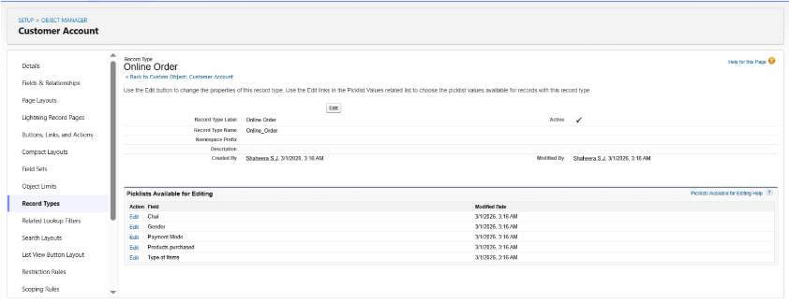

Walk-In Order Record Type
- Record Type Label: Walk-In Order
- Based on: Master Record Type
- Status: Active
- Assigned Page Layout: Walk-In Orders
The implementation of record types ensures structured segregation of online and offline customer data.

Milestone 9 – Validation Rules Implementation
Validation rules were implemented to maintain data integrity and prevent incorrect entries.

Employer Account Validation Rules
Aadhar Number Validation Rule
Ensures:
- Exactly 12 digits
- Numeric values only
- Does not start with zero
PAN Number Validation Rule
Ensures:
- Field is not blank
- Valid numeric format
- No special characters
- Does not start with zero
Phone Number Validation Rule
Ensures:
- Exactly 10 digits
- Numeric characters only
- No special symbols or spaces
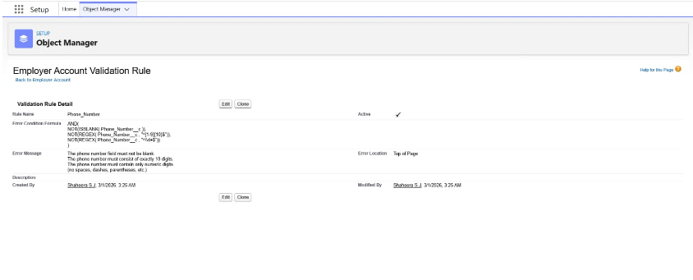

Customer Account Validation Rule
Phone number validation implemented with identical logic to maintain standardization.
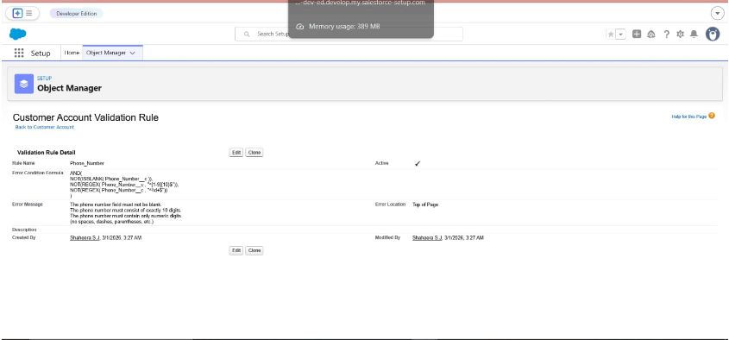

Enterprise Account Validation Rule
Phone number validation rule implemented to ensure consistent data formatting across all objects.
These rules enhance data accuracy and reduce manual errors.

Milestone 10 – Email Automation Setup

Birthday Email Template
A Classic Text Email Template titled Birthday Offer Email was created.
Subject:
Special Birthday Offer Inside!
The template includes merge fields to dynamically insert the customer’s first name.
The email content provides a 50% birthday discount offer using a promotional code, strengthening customer engagement and retention.
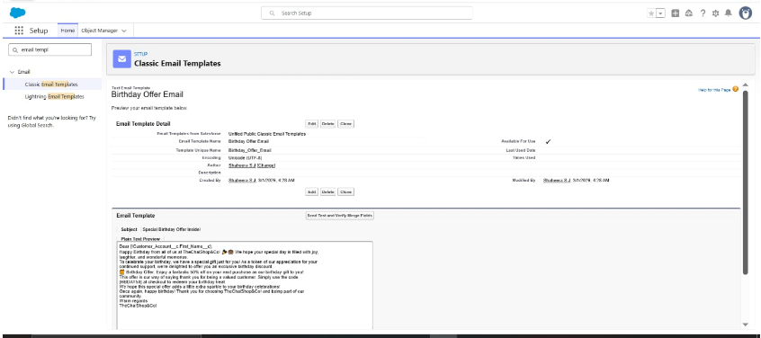

Email Alert Configuration
An Email Alert titled Happy Birthday Email Alert was configured on the Customer Account object.
Configuration Details:
- Associated Email Template: Birthday Offer Email
- Recipient: Customer Email ID
- Sender: Default Workflow User
This alert enables automated communication upon trigger conditions.
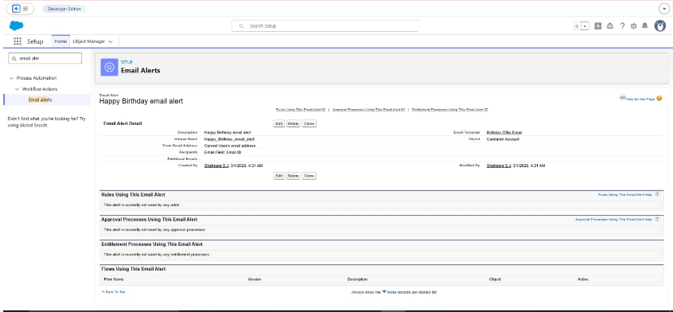

Milestone 11 – Flow Automation
A Scheduled Triggered Flow was developed to automate birthday email notifications.
Flow Details:
- Flow Type: Schedule-Triggered Flow
- Frequency: Daily
- Object: Customer Account
Conditions:
- Birthday Today Formula Field = True
- Email ID is not null
Action Implemented:
- Email Alert: Happy Birthday Email Alert
- Record ID passed dynamically
The flow was activated to ensure automatic daily execution.
This automation enhances customer experience through personalized communication.
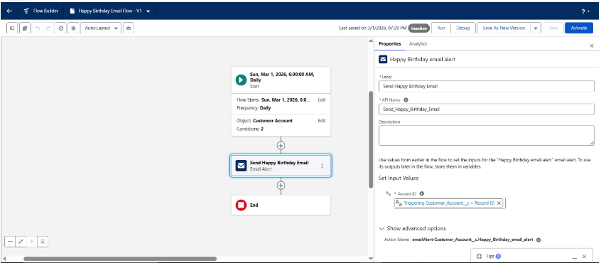
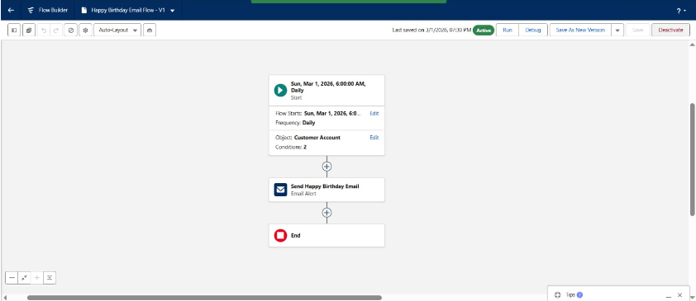
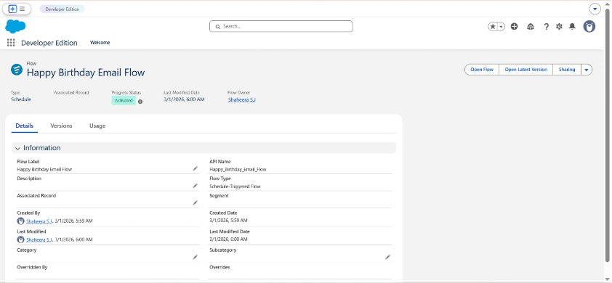

Milestone 12 – Reports and Dashboards

Customer Account Sales Report
A report titled Customer Account Sales Report was created using the Customer Accounts report type.
Features:
- Required columns added
- Grouped by Record Type
- Chart visualization enabled
This report provides insights into online versus walk-in sales performance.

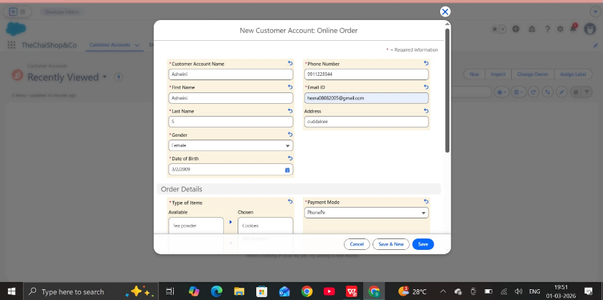
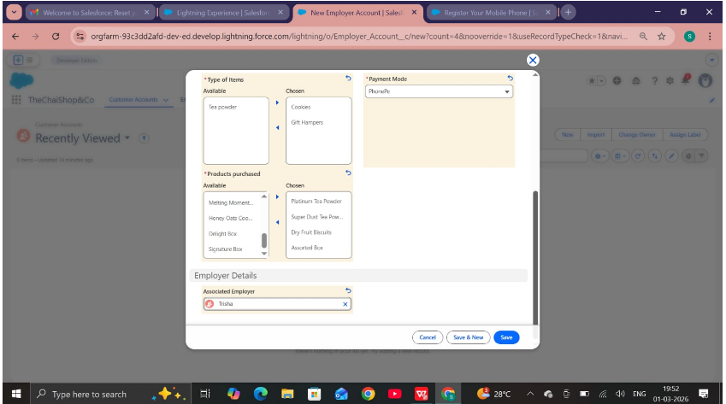
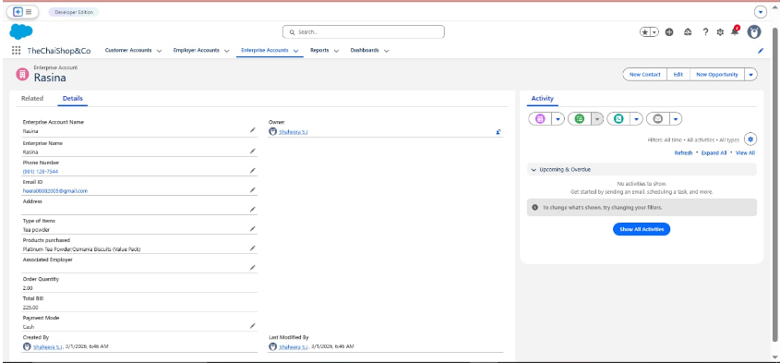
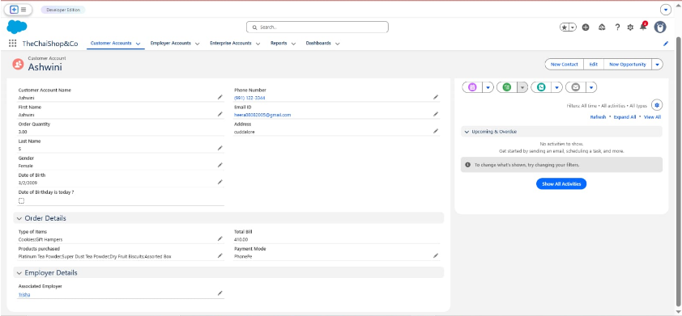

Enterprise Account Sales Report
A second report titled Enterprise Account Sales Report was developed.
Features:
- Grouped by Type of Items
- Chart visualization enabled
This report supports enterprise-level sales analysis.
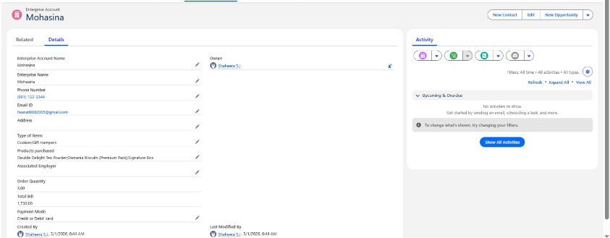
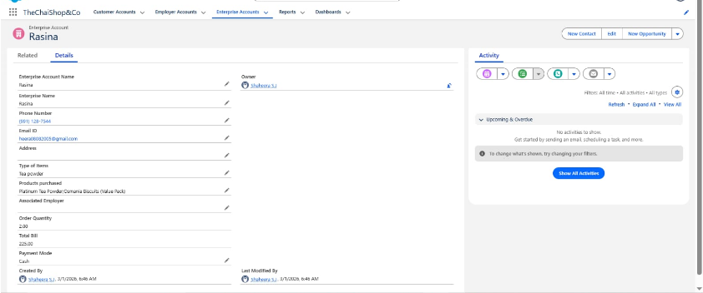
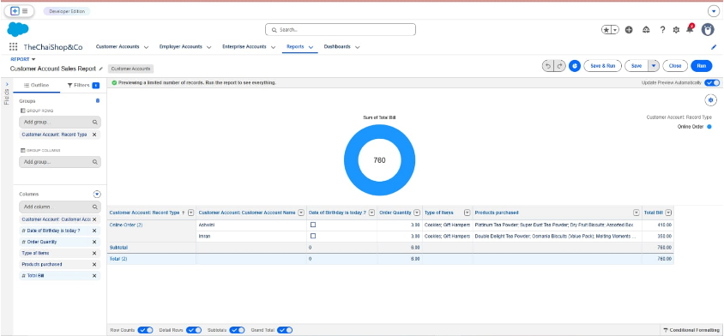
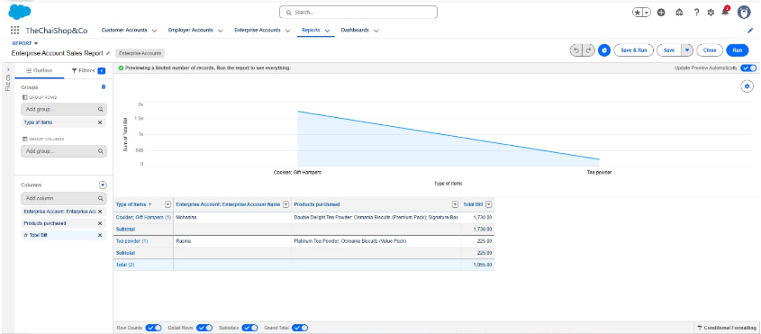

Dashboard Creation
A dashboard titled Customer Vs Enterprise Sales was created.
Components:
- Customer Account Sales Report Widget
- Enterprise Account Sales Report Widge
The dashboard provides comparative visual insights for strategic decision-making.
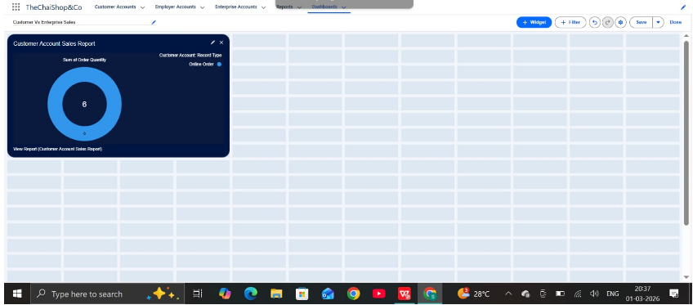
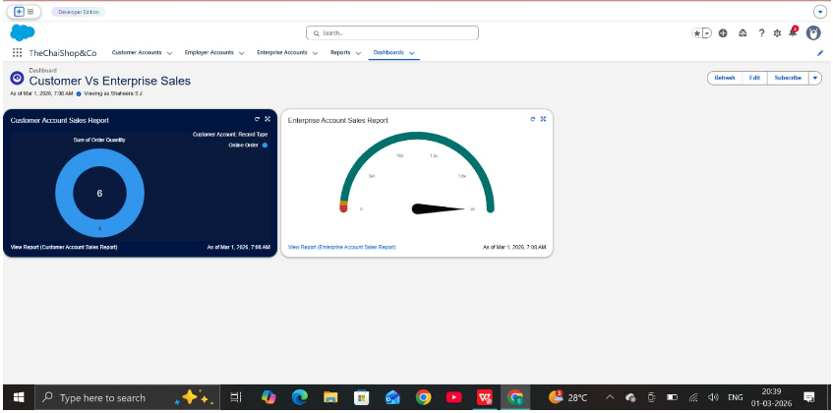

7. FUNCTIONAL & PERFORMANCE TESTING
Functional testing was conducted to validate system behavior within the Salesforce Lightning environment.
Testing Covered:
- Record creation for Employer, Customer, and Enterprise objects
- Validation rule verification
- Record type and page layout validation
- Formula field calculations
- Scheduled flow execution
- Report and dashboard functionality
Performance testing confirmed stable operation and responsive system behavior under concurrent usage conditions.

8. ADVANTAGES & DISADVANTAGES

Advantages
- Centralized data management
- Reduced manual processing
- Automated billing calculations
- Enhanced customer engagemen
- Real-time reporting and analytics

Disadvantages
- Requires Salesforce licensing
- Internet dependency
- Limited offline accessibility

9. CONCLUSION
The CRM Application for TheChaiShop&Co successfully enhances operational efficiency by integrating customer, employer, and enterprise data into a unified system. Automated billing calculations reduce human error, while scheduled email notifications strengthen customer relationships. Reports and dashboards enable informed business decisions through data-driven insights.

10. FUTURE SCOPE
- Mobile CRM integration
- AI-based sales forecasting
- WhatsApp and SMS notifications
- Inventory management integration
- Multi-branch operational support
- Advanced customer profiling and analytics

11. APPENDIX
Source Code: Salesforce Configuration and Flows
Dataset: Customer and Sales Records
Tools Used: Salesforce Developer Organization

